---->>>First On baremetal, I installed ubuntu desktop 14.04LTS. On Ubuntu i installed kvm and created (or) spinned up VMs on ubuntu.
My Host machine IP is 192.168.2.182. Here I created one virtual bridge(NAT) whiich will provide IP's for spinned VMs. These IPs are in 192.168.100.160.....
http://www.howtogeek.com/117635/how-to-install-kvm-and-create-virtual-machines-on-ubuntu/
https://help.ubuntu.com/community/KVM/Installation
ubuntu@ubuntu-XS23-TY3:~$ grep --color vmx /proc/cpuinfo
ubuntu@ubuntu-XS23-TY3:~$ egrep -c '(svm|vmx)' /proc/cpuinfo
16
ubuntu@ubuntu-XS23-TY3:~$ sudo apt-get install qemu-kvm libvirt-bin bridge-utils virt-manager
$ sudo apt-get install qemu-kvm libvirt-bin ubuntu-vm-builder bridge-utils qemu-system
1)libvirt-bin package installed
2)the libvirtd deamon started
$ ps -eo 'tty,pid,comm' | grep ^? --->To list all running deamons
3)our user is the member of libvirtd group.
To comnnect to virt manager these three conditions should be satisfied.
ubuntu@ubuntu-XS23-TY3:~$ sudo adduser ubuntu libvirtd
The user `ubuntu' is already a member of `libvirtd'.
ubuntu@ubuntu-XS23-TY3:~$ sudo useradd ceph
ubuntu@ubuntu-XS23-TY3:~$ sudo adduser ceph libvirtd
Adding user `ceph' to group `libvirtd' ...
Adding user ceph to group libvirtd
Done.
ubuntu@ubuntu-XS23-TY3:~$ logout
ubuntu@ubuntu-XS23-TY3:~$ virsh -c qemu:///system list
Id Name State
----------------------------------------------------
$virt-manager
(to start virtual machine manager with UI), before this you have to start X-ming.)
http://wiki.libvirt.org/page/TaskNATSetupVirtManager
http://wiki.libvirt.org/page/VirtualNetworking#Creating_a_virtual_network
================================================================================================================================================

http://www.howtogeek.com/117635/how-to-install-kvm-and-create-virtual-machines-on-ubuntu/
https://help.ubuntu.com/community/KVM/Installation

[17:23] <rock> Hi. I have downloaded "OpenStack base bundle" and integrated our charm with the bundle. Before populating bundle to store as our own bundle we want to deploy bundle from our local MAAS setup. I mean, I will make it as [MAAS+openstack base bundle] setup. Can I configure [MAAS+openstack base] setup using a single server.
[17:24] <rock> Can we configure [MAAS+OpenStack base bundle] setup on virtual machines? Please provide me the detailed information.
[00:36] <marcoceppi> You can use KVM machines
[00:38] <marcoceppi> http://maas.io/docs/installconfig-add-nodes

[12:09] <rock> Ok. Thank you.

https://jujucharms.com/u/openstack-charmers-next/openstack-base-trusty-mitaka
https://jujucharms.com/u/openstack-charmers-next/openstack-base-xenial-mitaka

[19:55] <rock_> Hi. I want to use KVM machines for maas setup using http://maas.io/docs/installconfig-add-nodes. So I created one kvm machine for maas-admin node. From that machine I ran $sudo virsh list --all. It was returning empty. Please provide me solution for this.

[20:13] <roaksoax> rock_: i think you have the wrong conception of what KVM/virsh do
[20:14] <roaksoax> rock_: if you do: sudo virsh list --all -> that will list of KVM's VM's running on the system where you are running that command
[20:14] <roaksoax> rock_: if that's a VM, it is most likely you don't have nested VM's on that machine
[20:14] <roaksoax> rock_: so you need to log into a external KVM/libvirt, to be able to list running VM's
[20:16] <rock_> roaksoax: Thank you. I have a question with KVM machines maas setup.
[20:16] == PCdude [6dc998f6@gateway/web/cgi-irc/kiwiirc.com/ip.109.201.152.246] has joined #maas
[20:18] <roaksoax> rock_: so, are you running MAAS as a VM right ?
[20:18] <roaksoax> rock_: so say, MAAS is in subnet 192.168.122.0/24, and your KVM host is 192.168.122.1/24 right ?
[20:19] <rock_> roaksoax: Yes.
[20:20] <roaksoax> rock_: so you'd need to do something like: virsh -c qemu+ssh://192.168.122.1/system list --all
[20:20] <roaksoax> rock_: so you'd need to do something like: virsh -c qemu+ssh://<user>@192.168.122.1/system list --all
[20:21] <rock_> roaksoax: I created one kvm machine for MAAS installation It has taken 192.168.122.98 [DHCP]
[20:22] <roaksoax> rock_: right, so you need to:
[20:22] <roaksoax> 1. configure you MAAS VM with static IP address
[20:22] <roaksoax> 2. disable libvirt DHCP, or it wont let MAAS provide DHC{P
[20:24] <rock_> roaksoax: So can I configure static IP for MAAS VM using 192.168.122.0/24 range IP.
[20:26] <rock_> roaksoax: For remaining 4 maas-slave nodes, No need to install OS. Enabling pxe boot is sufficient? Then MAAS will do auto discovery ?
[20:28] <rock_> roaksoax: (or) for adding nodes manually, I need power ID and adress of slave nodes right. Power ID means name of slave-node. So How can I get power address?
[20:29] <roaksoax> rock_: so do 1 and 2 above, then name the VM's maas will control somthing different from MAAS< for example:
[20:29] <roaksoax> maas-server, node01,node02, etc (in livirt)
[20:30] <roaksoax> rock_: 3. name your MAAS VM vs your node's differently, so they have a different prefix
[20:31] <roaksoax> rock_: 4. Go to MAAS, click on 'Add Chassis', and input for power address: qemu+ssh://<user>@192.168.122.1/system power password: your psasword, prefix filter - a prefix to import all of those machines that start with that prefix (that does NOT match the MAAS server)
[20:31] <roaksoax> rock_: 5. configur DHCP in MAAS
[20:31] <roaksoax> rock_: 6. Download images in MAAS
[20:34] <rock_> roaksoax: OK. Thank you. So I have give the same power address :qemu+ssh://<user>@192.168.122.1/system power for all slave nodes right. In MAAS node am I need to create a bridge (or) router kind of thing.
[20:35] <roaksoax> rock_: no, since they are all vm's, theu will all access the internet via the KVM host machine
[20:35] <roaksoax> rock_: via 192.168.122.1
[20:35] <roaksoax> rock_: if you were running maas in the KVM host machine (uinstead of inside a VM), they you may need to create a bridge

========================================================================================================================================================
->Created One KVM Machine with Ubuntu 14.04
->Did System Update and Upgrade
From KVM host , I listed KVM VM’s
vedams@vedamsa013d8:~$ sudo virsh list --all
Id Name State
----------------------------------------------------
12 maas-server running

1. configure you MAAS VM with static IP address
->/etc/network/interfaces made static IP
2. disable libvirt DHCP, or it wont let MAAS provide DHCP
http://www.krisbuytaert.be/blog/disabling-dhcp-libvirt-setup
So you have this libvirt setup and you want to have a dhcp server on the virtual machines you are playing with , or you want to have all static IP's.
Libvirt uses dnsmasq to provide dhcp services. If you fully remove the dhcp section, then restart libvirt you'll notice dnsmasq running with no dhcpd on that subnet .

->Go to KVM Host machine,
vedams@vedamsa013d8:/var/lib/libvirt/network$ vi default.xml
Comment dhcp part
root@vedamsa013d8:/var/lib/libvirt/network# virsh net-edit default
<network>
<name>default</name>
<uuid>ba7fc590-fa00-4f48-b4a3-b563cbce0b84</uuid>
<forward mode='nat'/>
<bridge name='virbr0' stp='on' delay='0'/>
<mac address='52:54:00:e6:35:3d'/>
<ip address='192.168.122.1' netmask='255.255.255.0'>
<!--
Commented DHCP part
-->
</ip>
</network>
sudo service libvirt-bin restart
Now Libvirt DHCP disabled.

->Installed MAAS packages On that machine
http://www.ubuntu.com/download/cloud

Able to Open MAAS UI.

Facing issue while creating maas-slave node with PXE boot enable Option.
http://askubuntu.com/questions/267435/how-to-pxe-boot-a-virtual-machine-from-another-virtual-machine-which-are-in-same

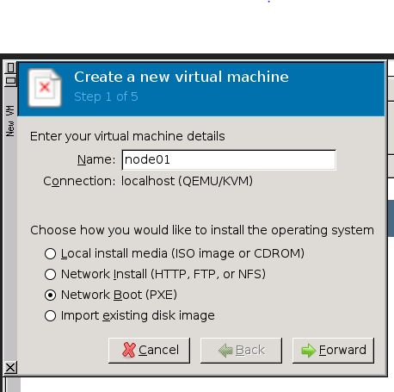

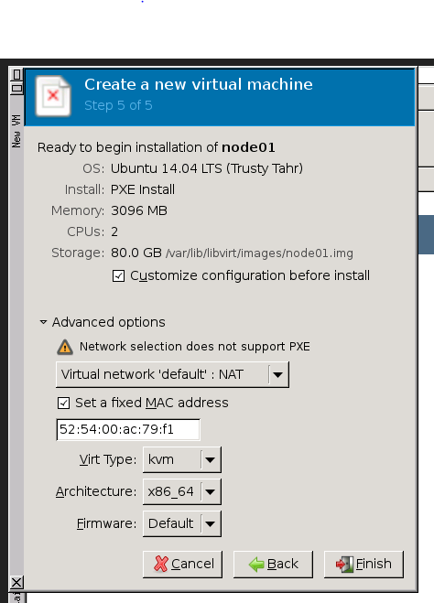
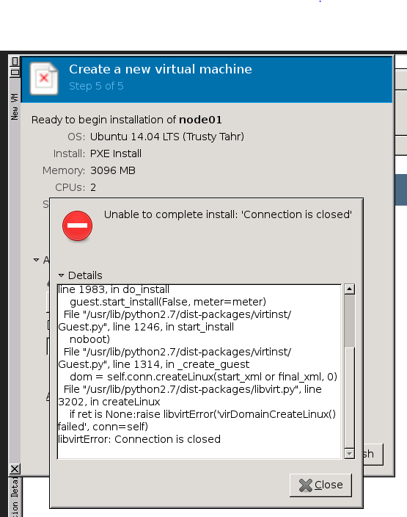
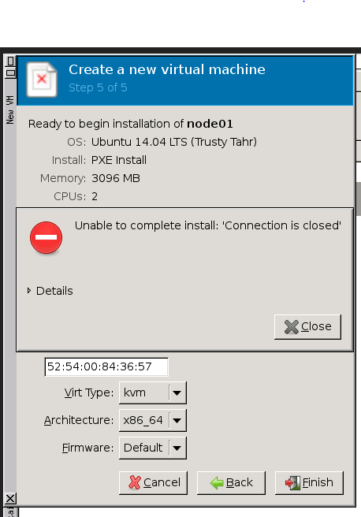
https://wiki.ubuntu.com/QemuPxe

